Week-4 MICROSERVICES
Creating Microservices for account and loan
AccountController.java:
package com.cognizant.account.controller;
import org.springframework.web.bind.annotation.*;
import java.util.Map;

@RestController
@RequestMapping("/accounts")
public class AccountController {

@GetMapping("/{number}")
public Map<String, Object> getAccountDetails(@PathVariable String number) {
return Map.of(
"number", number,
"type", "savings",
"balance", 234343
);
}
}

OUTPUT: http://localhost:8080/accounts/00987987973432
Browser
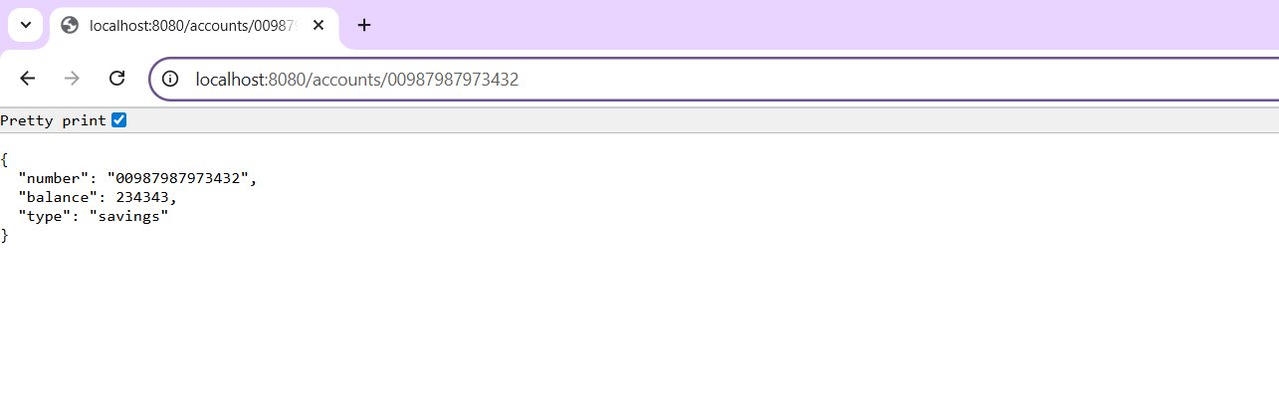
Postman:
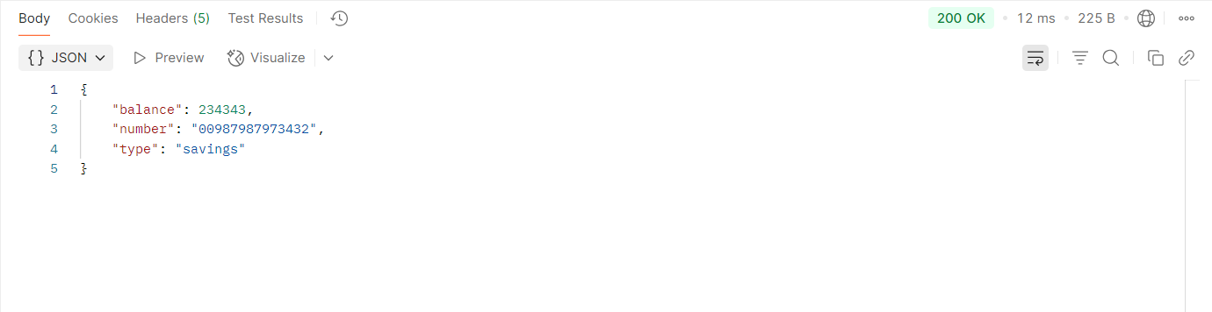

LoanController.java:
package com.cognizant.loan.controller;

import org.springframework.web.bind.annotation.*;
import java.util.Map;

@RestController
@RequestMapping("/loans")
public class LoanController {

@GetMapping("/{number}")
public Map<String, Object> getLoanDetails(@PathVariable String number) {
return Map.of(
"number", number,
"type", "car",
"loan", 400000,
"emi", 3258,
"tenure", 18
);
}
}

OUTPUT: http://localhost:8081/loan/H00987987972342
Browser
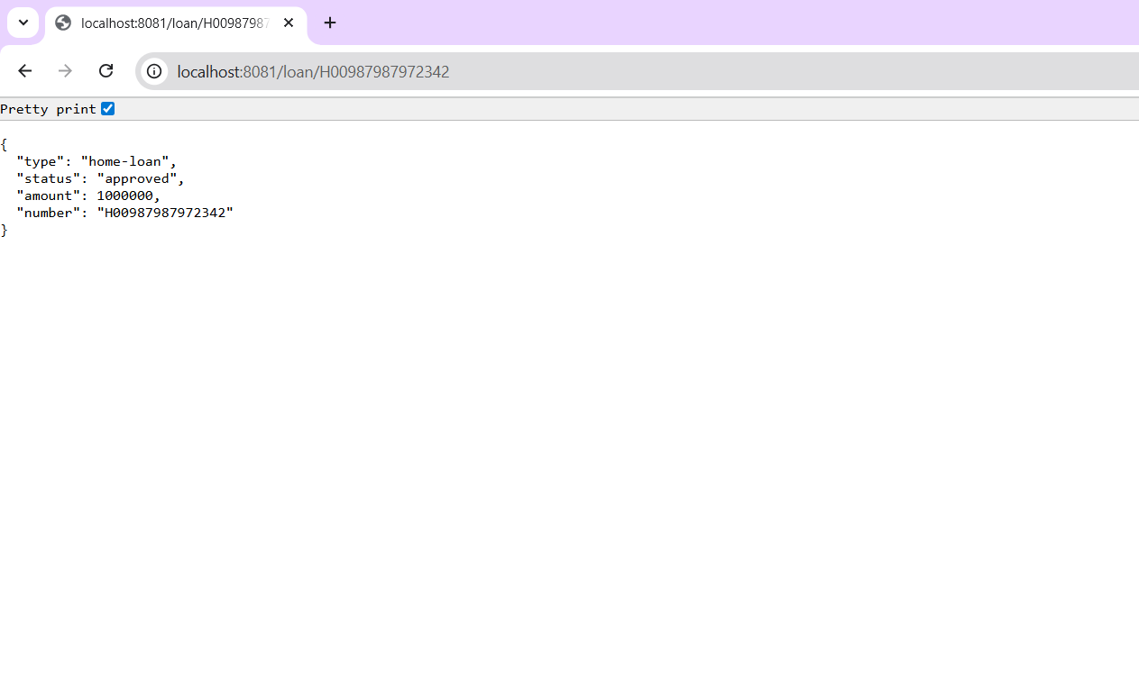
Postman
